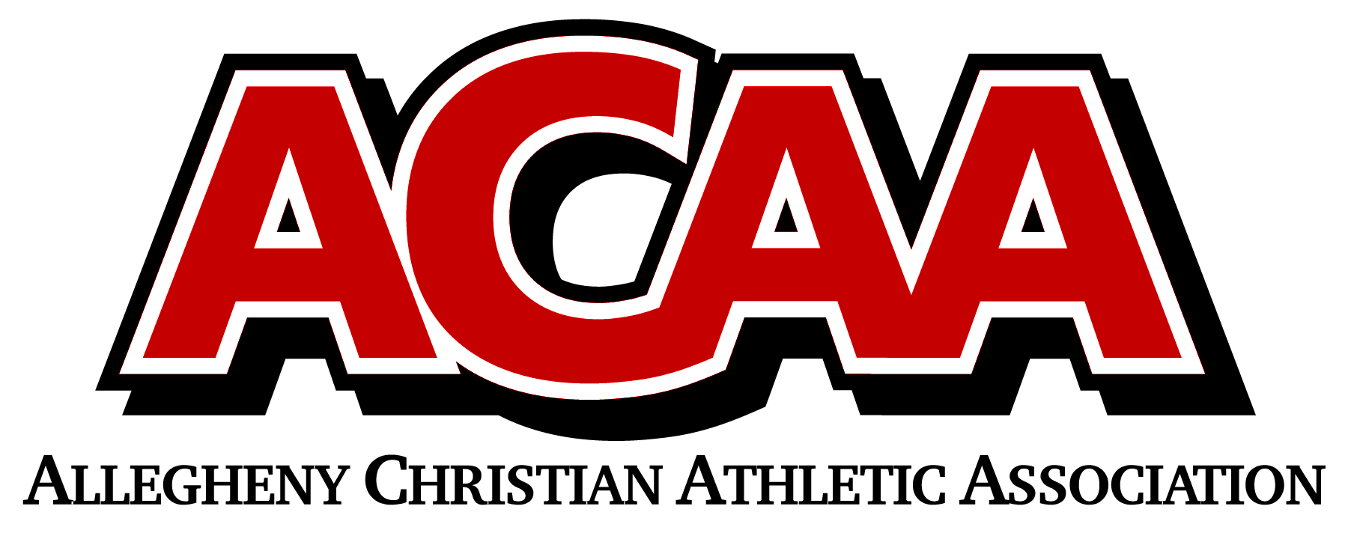

ACAA Pregame Basketball Sportsmanship Message

“The ACAA and its member schools have made a commitment to promote good sportsmanship by students/athletes, coaches, and spectators before, during, and following all ACAA sanctioned events.

The ACAA values your positive, constructive, and courteous support for both athletes and officials. Cheers and comments should encourage and not be degrading to opponents, fans, or officials. Profanity, degrading remarks, and intimidating actions directed at officials or competitors will not be tolerated, and are grounds for removal from the event site.

Thank you for your cooperation in the promotion of good sportsmanship at today’s event.”

